Joe's Video Store — The Full Walkthrough
View 1 → View 2 → Merge → Final ERD

The Overall Roadmap

JOE'S VIDEO STORE DATABASE

VIEW 1
Customer Rents Video
|
0NF -> 1NF -> 2NF -> 3NF
|
VIEW 1 ERD
|
------------------------
|
VIEW 2
Video Information
|
0NF -> 1NF -> 2NF -> 3NF
|
VIEW 2 ERD
|
------------------------
|
MERGE THE VIEWS
|
FINAL DATABASE ERD

Part 1 — View 1: Customer Rents Video

This is your scenario:

Normalization Exercise: Joe’s Video Store - View 1

Joe wants you to develop a small database application to help him run his video rental store.
Tracking information to rent a video is one system requirement.
You are to develop a view schema in 3NF for the Customer Rents Video view.
A sample screen layout is shown below:

Joe’s Video Store: Video Rentals
Transaction ID: 1 | Date: May 18, 2006

Customer ID: 12345 | Name: Mira Washington
Phone: 962-6190 | Address:
  76 Pacific Ave
  My Town, Alberta
  T3J 2X0

Video ID | Copy  Number | Title | Return  Date | Rental Charge
Hor-1 | 1 | Carrie | May 21, 2006 | 3.00
Hor-2 | 3 | The Exorcist | May 21, 2006 | 3.00
Rom-1 | 1 | As Good As It Gets | May 19, 2006 | 5.00
 |  |  | Subtotal: | 11.00
 |  |  | GST: | 0.77
 |  |  | Total: | 11.77

Business Rules:

- A customer may have a maximum of ten videos rented simultaneously.
- Joe knows the rental charges change over time, so he wants the system to record the rental charge for each video on a transaction (historical information) as well as record the current rental charge for each video.
- Transaction ID, Customer ID and Video ID are unique.
- Copy Number is unique within Video ID (the first copy of any given video is copy number 1).
- You are to produce a view schema in 3NF. Show the schema in ERD notation. Document any assumptions you make.

Step 1 Read the Business Rules First
Identify:
Entities hiding in the screen
- Customer
- Transaction
- Video
- Video Copy
"Which one can repeat?"
→ The answer is the videos on a transaction. One transaction can contain multiple rented videos. So we already know we're going to have a repeating group.

Method 1: Ask the "One-to-Many" Question
For each attribute, ask:
"For one [main thing], can this attribute have multiple values?"
you're given this flat list for View 1:
TransactionID
TransactionDate
CustomerID
Name
Phone
Address
VideoID
CopyNumber
Title
ReturnDate
RentalCharge
HistoricalRentalCharge
SubTotal
GST
Total

Attribute | For one transaction, can this have many values? | Repeats?
TransactionID | No — one per transaction | No
TransactionDate | No — one per transaction | No
CustomerID | No — one customer per transaction | No
Name | No — one customer name | No
Phone | No — one phone | No
Address | No — one address | No
VideoID | Yes — one transaction can have many videos | Yes
CopyNumber | Yes — each video has its own copy | Yes
Title | Yes — each video has a title | Yes
ReturnDate | Yes — each video has its own return date | Yes
RentalCharge | Yes — each video has its own charge | Yes
HistoricalRentalCharge | Yes — each video has its own historical charge | Yes
SubTotal | No — one per transaction | No
GST | No — one per transaction | No
Total | No — one per transaction | No
So block from VideoID through HistoricalRentalCharge repeats. That's your repeating group.
So you add the parentheses: TransactionID,TransactionDate,CustomerID,Name,Phone,Address,(VideoID,CopyNumber,
Title,ReturnDate,RentalCharge,HistoricalRentalCharge),SubTotal,GST,Total

Method 2: Look for "Detail" or "Line Item" Words
In the scenario description, look for phrases like:
- "multiple rented videos on a transaction"
- "a transaction can contain many..."
- "each transaction may include several..."
- "line items"
- "details"
These phrases tell you there's a repeating group. They're the business rule.
In the View 1 scenario, the description says:
"multiple rented videos on a transaction"
That single phrase is the clue. It tells you the video information repeats.

Method 3: Think About What a Real Receipt Looks Like
Look at your receipt:
Which lines appear more than once? → The video lines.
Those columns are the repeating group.
Hor-1 | 1 | Carrie | May 21, 2006 | 3.00
Hor-2 | 3 | The Exorcist | May 21, 2006 | 3.00
Rom-1 | 1 | As Good As It Gets | May 19, 2006 | 5.00

In separate word file you are given Attributes:
Transaction ID
Transaction Date
Customer ID
Customer First Name
Customer Last Name
Customer Phone
Customer Street Address
Customer City
Customer Province
Customer Postal Code
Video ID
Video Copy Number
Video Title
Video Return Date
Video Rental Charge Current
Video Rental Charge Historical
Transaction GST

This is a beginning of your 0NF as it already split some attributes into atomic
Our 0NF steps are:
Identify the PK and any repeating group(s) of attributes.
- PKs must always be unique, and may be made up of more than 1 column.
- A repeating group is 1+ attributes that can have multiple values for a single instance of an entity at the same time.
So after using one of 3 methods or all you will write your attributes as follows:
TransactionID,TransactionDate,CustomerID,Name,Phone,Address,(VideoID,CopyNumber,
Title,ReturnDate,RentalCharge,HistoricalRentalCharge),SubTotal,GST,Total
The most important thing to notice: the parentheses ( ... ). Parentheses means "this part can repeat." That's the repeating group. Visually, think of it like this:
TRANSACTION
|
+-- TransactionID
+-- TransactionDate
+-- CustomerID
+-- Customer information
|
+-- (VIDEO INFORMATION) ← repeats
+-- VideoID
+-- CopyNumber
+-- Title
+-- ReturnDate
+-- RentalCharge
+-- HistoricalRentalCharge
Step 3 — 1NF
"What violates 1NF?"
A table MUST contain only atomic attributes.(this was fixed for you)
2. A table cannot contain any repeating groups of attributes.( you have already identified repeating group)
If a repeating group of attributes exists:
1. Move the repeating group of attributes to a new table.
2. Copy the PK of original and place in new table as FK.
3. Designate cardinality of relationship between entities.(its better to do it here as you will get more confused if you don’t)
4. Designate a PK for the new table.
In example we have 2 violations:
Violation 1: repeating group
(VideoID, CopyNumber, Title, ReturnDate, RentalCharge, HistoricalRentalCharge)

Violation 2: composite attributes this was fixed for you in the attributes list provided, you can skip this step
Step 4 — Move the Repeating Group to a new table
We're not just shuffling columns. We're creating a child entity because one transaction can contain many videos.
The relationship becomes:
TRANSACTION 1 --------- M TRANSACTION DETAIL
Transaction Transaction Detail
TransactionID (PK)
TransactionDate
CustomerID
FirstName
LastName
Phone
Address
City
Province
PostalCode
SubTotal
GST
Total
TransactionID PK/FK
VideoID PK/FK
CopyNumber PK(all 3 create composite key)
Title
ReturnDate
RentalCharge
HistoricalRentalCharge
How to Understand the Composite Key
Question: Can TransactionID alone identify a row in Transaction Detail? → No. One transaction has many videos.
Question: Can VideoID alone identify a row? → No. A video can appear in many transactions.
Question: What identifies one rental line? → The combination: TransactionID + VideoID + CopyNumber That's why the old worksheet shows multiple attributes becoming the PK. It's showing you the composite key.
Step 5 — 2NF
Rules:
1. All non-key attributes in a table must fully depend on the entire PK of the table.
A violation can only occur in a table with a composite primary key — if we don't have one, we're done with 2NF!
Are there any attributes that only rely on part of the PK? If so, we have a violation — this is called a partial dependency.
If a partial dependency exists:
1. Move the partially dependent attribute to a new table.
2. Copy the part of the PK it's dependent on, and place in new table as PK (it's now an FK in the original table).
3. Designate cardinality of the relationship.
We definitely have composite key so its first violation!
2NF rule: Only look for partial dependencies in tables that have a composite primary key.
- Transaction has a single PK (TransactionID). → No 2NF violation, this table is fine.
- Transaction Detail has a composite key. → We must change it.
Does Title depend on the whole key (TransactionID + VideoID + CopyNumber)?
→ No. Title depends only on VideoID. Same for RentalCharge. So we mmake new table Video where VideoID is PK:
VIDEO
VideoID PK
Title
RentalCharge
2NF Result is 3 entities with3 tables:
TRANSACTION TRANSACTION DETAIL VIDEO
TransactionID (PK)
TransactionDate
CustomerID
FirstName
LastName
Phone
Address
City
Province
PostalCode
SubTotal
GST
Total
TransactionID(PK/FK)
VideoID (PK/FK)
CopyNumber
ReturnDate
HistoricalRentalCharge
VideoID (PK)
Title
RentalCharge
Step 6 — 3NF
Rules:
1. A non-key attribute cannot be fully dependent on another non-key attribute.
A non-key attribute that is fully dependent on another non-key attribute (instead of the PK) is called a transitive dependency.
To fix:
1. Move the transitively dependent attribute to a new table.
2. Copy the non-key attribute it was dependent on and place in new table as PK (it's now a FK in the original table).
3. Designate cardinality of the relationship. (optional)
Look at Transaction. We have:
TransactionID (PK)
TransactionDate
CustomerID
FirstName
LastName
Phone
Address
City
Province
PostalCode
SubTotal
GST
Total

So customer information doesn't belong in Transaction make new table:
CUSTOMER TRANSACTION (NEW WITHOUT CUSTOMER INFO)
CustomerID (PK)
FirstName
LastName
Phone
StreetAddress
City
Province
PostalCode
TransactionID(PK)
TransactionDate
CustomerID (FK)
Connects to customer
Table)
SubTotal
GST
Total
Step 9 — View 1 ERD
Assign relationships and use crow foot notation to make ERD for all of it
CUSTOMER
|
| 1:M
v
TRANSACTION
|
| 1:M
v
TRANSACTION DETAIL
|
| M:1
v
VIDEO

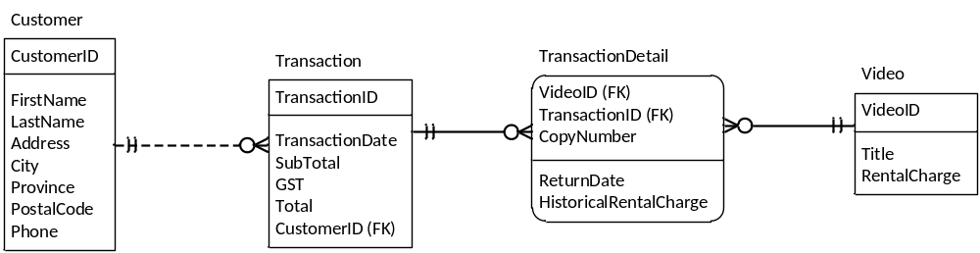

Part 2 — View 2: Video Information

Normalization Exercise: Joe’s Video Store - View 2
Joe wants you to develop a small database application to help him run his video rental store. Tracking video information is one system requirement.
You are to develop a view schema, in 3NF for the Video information view.
A sample screen layout is shown below:

Joe’s Video Store: Video Information
Video Id: Hor-1 | Title: Carrie

Type Id: 1 | Type Name: Horror Movie
Total no of copies: 5 | No of copies available for rental: 2
Format: VHS  Cost: $9.00 | Rental Charge: $3.00  Rating Code: R  Rating Description: Restricted Adult

Copy  Number | Available for  rental
1 | no
2 | no
3 | Yes
4 | Yes
5 | no

Business Rules:

- Movie Types are: Horror, Comedy, Action, Romance, Science fiction,..
- Formats are: VHS, VCD, DVD.
- Movie Ratings are: Children, Youth, Adult, Restricted Adult, and X-Rated
- Copy Number is unique within Video Id (the first copy of any given video is copy number 1).

You are to produce a view schema in 3NF. Document any assumptions you make.
Merge this user view with the Video rentals user view.
The View 2 source contains Video ID, title, type, format, rental charge, cost, rating, and a repeating group for copies.
LETS REPEAT ALL THE STEPS AGAIN!
Step 1 — View 2 Initial Table and Business Rules
Identify:
"Which one can repeat?"
You are given following attribute list, again its split into atomic already
Video ID
Video Title
Video Type ID
Video Type Name
Number Of Total Copies
Number Of Available Copies
Video Format ID
Video Format Description
Video Rental Charge
Video Cost
Video Rating Code
Video Rating Description
Video Copy Number
Available For Rental
Again: parentheses = repeating group (use one of the methods explained earlier).

VideoID (PK), Title, TypeID, TypeName, NumberOfCopies, NumberOfAvailableCopies, Format, RentalCharge, Cost, RatingCode, RatingDescription,(CopyNumber, AvailableForRental)
So visually it will look like this:
VIDEO
|
+-- VideoID
+-- Title
+-- Type
+-- Format
+-- Rental information
+-- Rating
|
+-- (COPY)
+-- CopyNumber
+-- AvailableForRental
Step 2 — View 2: 1NF
Rules:
A table MUST contain only atomic attributes.(this was fixed for you)
2. A table cannot contain any repeating groups of attributes.( you have already identified repeating group)
If a repeating group of attributes exists:
1. Move the repeating group of attributes to a new table.
2. Copy the PK of original and place in new table as FK.
3. Designate cardinality of relationship between entities.(its better to do it here as you will get more confused if you don’t)
4. Designate a PK for the new table.
Video Video Copy
VideoID(PK)
Title
TypeID
TypeName
Format
RentalCharge
Cost
RatingCode
RatingDescription
VideoID (FK/PK)
CopyNumber(FK/PK)
AvailableForRental
And VideoID is copied from the parent into the new table.
"What is the key of Video Copy?"
→ Neither VideoID nor CopyNumber alone is enough. So: VideoID + CopyNumber is the composite key.

Step 3 — View 2: 2NF
2NF — No Violation.
Why? Because:
VideoID + CopyNumber -> AvailableForRental
You need the whole key to identify the particular copy. So nothing is partially dependent.
"Not every table with a composite key automatically has a 2NF violation. You have to test the dependencies."
Step 4 — View 2: 3NF
Rules:
1. A non-key attribute cannot be fully dependent on another non-key attribute.
A non-key attribute that is fully dependent on another non-key attribute (instead of the PK) is called a transitive dependency.
To fix:
1. Move the transitively dependent attribute to a new table.
2. Copy the non-key attribute it was dependent on and place in new table as PK (it's now a FK in the original table).
3. Designate cardinality of the relationship. (optional)
Now look at Video table and following attributes: VideoID -> TypeID -> TypeName
Therefore TypeName moves to different table with different entity VIDEO TYPE:
VIDEO TYPE
TypeID (PK)
TypeName
Next we can move this to new table for VIDEO RATING : RatingCode -> RatingDescription
VIDEO RATING
RatingCode (PK)
RatingDescription
Next we can move this to new table for VIDEO FORMAT : FormatIDe -> FormatDescription
VIDEO FORMAT
FormatID PK
FormatDescription
Then Video contains the FKs.
Step 5 — View 2 Final Schema
VIDEO VIDEO COPY
VideoID (PK)
Title
VideoTypeID (FK
Connects to Video Type table)
NumberOfCopies
NumberOfAvailableCopies
FormatID {FK connects to Video Format table)
RentalCharge
Cost
RatingCode (FK Conects to Video Rating table)
VideoID (PK/FK connects to video table )
CopyNumber PK
AvailableForRental
RatingCode (PK)
RatingDescription
VIDEO TYPE VIDEO FORMAT VIDEO RATING
VideoTypeID (PK)
VideoTypeName
FormatID (PK)
FormatDescription

VIDEO ──────< VIDEO COPY
│
├── VIDEO FORMAT
└── VIDEO RATING
- One format can apply to many videos
- One rating can apply to many videos
- One video can have many copies

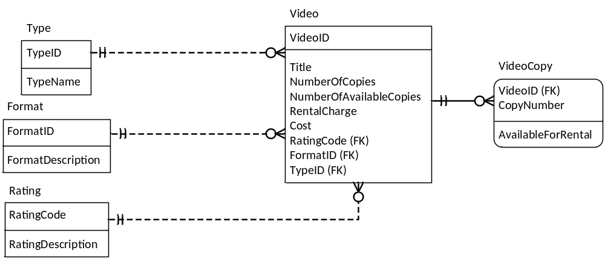Final ERD

Part 3 — Now Merge
"We did NOT design these two views independently because we want two separate Video tables. We designed each view separately because each view represents a different perspective of the same system."
Rules for merging:
Rule 1: Same Primary Key = Same Entity
If two tables from different views have the same primary key, they represent the same entity and must be merged.
Rule 2: Merge by Combining All Attributes
Rule 3: Keep All Relationships: After merging, preserve all relationships from both views.
Rule 4: Resolve Conflicting Attribute Names
Rule 5: Keep Different Facts Separate: If two attributes look similar but mean different things, keep both.
Rule 6: Merge Only When PKs Match: Do not merge tables just because they have similar names

When merging two tables with the same PK, combine all attributes from both into one table.

All entities from VIEW 1 | All entities from VIEW 2
CUSTOMER | VIDEO
TRANSACTION | VIDEO COPY
TRANSACTION DETAIL | VIDEO TYPE
VIDEO | VIDEO FORMAT
 | VIDEO RATING

"Do we have VIDEO twice?"
→ Yes.
"Do they represent the same entity?"
→ Yes.
"Do they have the same primary key?"
→ Yes: VideoID. Therefore: MERGE THEM.

Merge the Two VIDEO Tables
VIDEO Table from VIEW1 VIDEO Table from VIEW2
VideoID (PK)
VideoTitle
VideoRentalChargeCurrent
VideoID ( PK)
VideoTitle
VideoTypeID (FK)
NumberOfTotalCopies
NumberOfAvailableCopies
FormatID (FK)
VideoRentalCharge
VideoCost
RatingCode (FK)

We make it into one!
Rule 2: Merge by Combining All Attributes
VIDEO Table Merged (View1+View2)
VideoID PK
VideoTitle
VideoTypeID FK
NumberOfTotalCopies
NumberOfAvailableCopies
FormatID FK
VideoRentalChargeCurrent
VideoCost
RatingCode FK
Rule 3: Keep All Relationships
- Foreign keys from View 2 stay
- Relationships from View 1 stay
Rule 4: Resolve Conflicting Attribute Names
Resolve the Rental-Charge Issue
View 1 has: Historical Rental Charge — because the charge at the time of the transaction must be preserved.
View 2 has: Current Rental Charge — because the current price can change.
At first glance, these two attributes look like duplicates. They are not.
View 1 Name | View 2 Name | Merged Name
VideoRentalChargeCurrent | VideoRentalCharge | VideoRentalChargeCurrent
We have an issue here so lets solve it:
Rule 5: Keep Different Facts Separate: If two attributes look similar but mean different things, keep both.
Attribute | Meaning | Where It Lives
HistoricalRentalCharge | Price at time of rental | Transaction Detail
CurrentRentalCharge | Current price of video | Video
These are not duplicates. They are two different facts.

Rule 6: Merge Only When PKs Match
Do not merge tables just because they have similar names.
Table A | Table B | Same PK? | Merge?
VIDEO (VideoID) | VIDEO COPY (VideoID + CopyNumber) | No | No
VIDEO (VideoID) | VIDEO (VideoID) | Yes | Yes
The Merge Decision Table:
Question | Answer | Action
Do both views have a same table? | Yes | Continue
Do they represent the same entity? | Yes | Continue
Do they have the same PK? | Yes (VideoID) | Merge
Transaction Detail table after merging View 1 and View 2:
Transaction Detail
TransactionID PK/FK
VideoID PK/FK
CopyNumber PK
ReturnDate
HistoricalRentalCharge
Final Merged Structure
Attribute | Comes From | Why It Stays Here
TransactionID | View 1 | Identifies which transaction this line belongs to
VideoID | View 1 | Identifies which video was rented
CopyNumber | View 1 | Identifies which physical copy was rented
ReturnDate | View 1 | Fact about this specific rental
HistoricalRentalCharge | View 1 | Fact about this specific rental (price at time of rental)
What Was Removed and Why
Attribute | Was in View 1? | Where Did It Go? | Why?
Title | Yes | Video | Depends on VideoID, not the whole key (2NF violation)
RentalCharge | Yes | Video | Depends on VideoID, not the whole key (2NF violation)

What Was NOT Added from View 2
Attribute | Why It Does NOT Belong Here
CurrentRentalCharge | Fact about the video, not about this rental
NumberOfCopies | Fact about the video
AvailableForRental | Fact about the video copy
FormatID | Fact about the video
RatingCode | Fact about the video
Relationship
TRANSACTION (1) ─────< (M) TRANSACTION DETAIL (M) ─────< (1) VIDEO
- One transaction has many transaction detail lines
- Each transaction detail line refers to one video
- One video can appear in many transaction detail lines

